**Madiha Aimon Tappal**

[madihaaimon@gmail.com](mailto:madihaaimon@gmail.com)

**Data Engineering Batch – 1**

**Day – 26 Assignment**

**Azure Devops**

**Azure Synapse:**

Azure Synapse Analytics is a comprehensive cloud-based analytics service that integrates various data processing and analytics technologies to enable organizations to derive valuable insights from large volumes of data. It is designed to handle both traditional structured data and unstructured big data, providing a unified platform for data storage, processing, and analysis. Here are some key theoretical aspects of Azure Synapse Analytics:

1. **Unified Analytics Platform:**
   * Azure Synapse Analytics integrates data warehouse capabilities with big data processing. It unifies these traditionally separate systems into a single platform, allowing users to seamlessly analyze and visualize data from different sources.
2. **Data Integration:**
   * The service supports data integration from diverse sources, whether they are on-premises or in the cloud. It facilitates the extraction, transformation, and loading (ETL) processes to ensure that data is prepared for analysis.
3. **Data Warehousing:**
   * Azure Synapse Analytics serves as a data warehousing solution, providing a scalable and performant repository for structured data. Users can organize and store large volumes of data in a way that is optimized for analytics and reporting.
4. **Big Data Processing:**
   * The platform supports big data processing using Apache Spark, enabling users to analyze and derive insights from unstructured or semi-structured data. This is particularly useful for scenarios where traditional relational databases may not be the most efficient.
5. **Real-Time Analytics:**
   * Azure Synapse Analytics enables real-time analytics by supporting the processing of streaming data alongside batch data. This capability is crucial for organizations that need to make decisions based on up-to-the-minute information.
6. **Scalability and Performance:**
   * The service is designed to scale horizontally to handle growing amounts of data and increasing processing demands. It provides performance optimizations, such as distributed query processing, to deliver fast query results even for large datasets.
7. **Security and Compliance:**
   * Azure Synapse Analytics places a strong emphasis on security, offering features such as data encryption, identity and access management, and compliance with industry standards. This ensures that sensitive data is protected and that the platform meets regulatory requirements.
8. **Data Exploration and Visualization:**
   * Users can explore and visualize their data using various tools, including integration with Power BI. This empowers analysts and decision-makers to interact with data in a way that is meaningful and aids in the decision-making process.

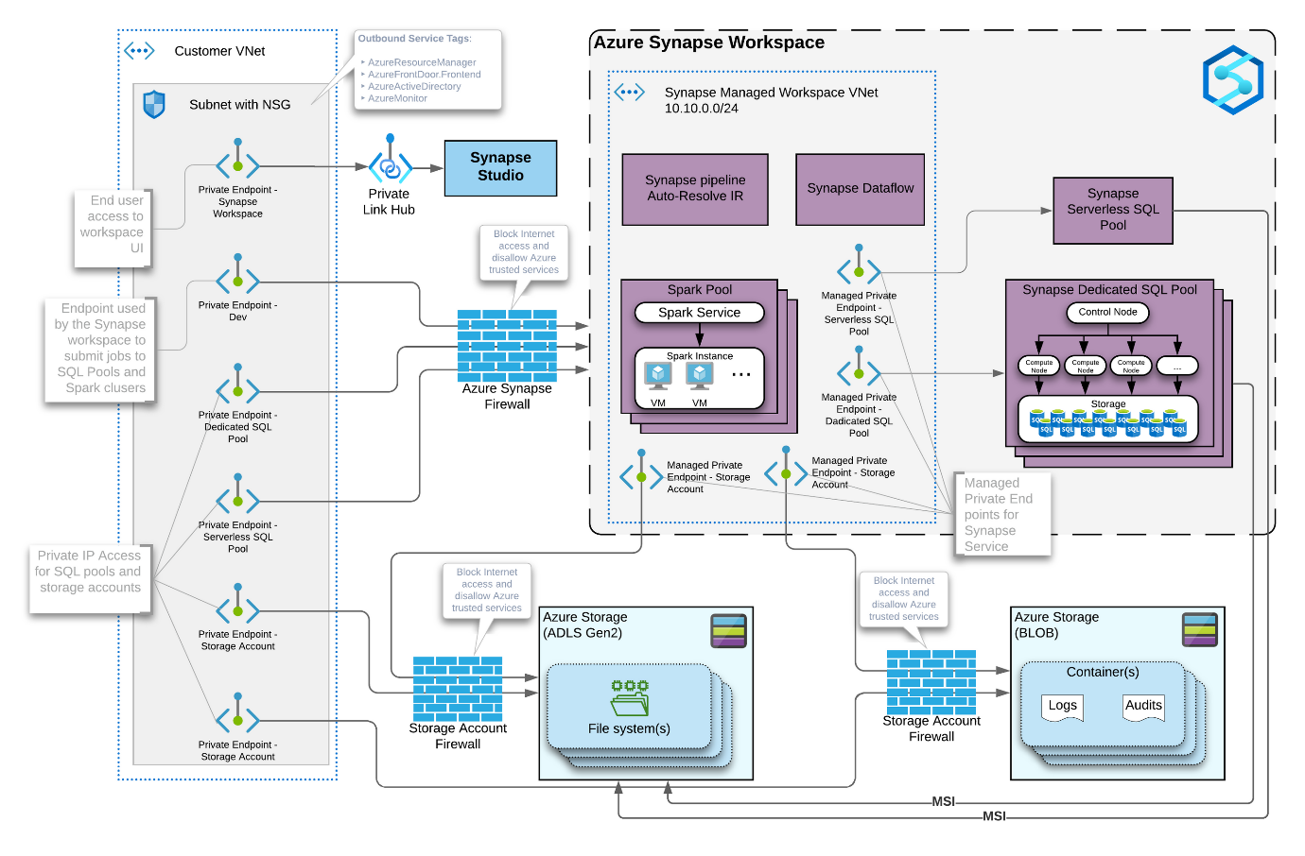

In summary, Azure Synapse Analytics provides a versatile and integrated analytics platform that brings together data warehousing and big data processing capabilities. Its unified approach aims to simplify the analytics workflow and support organizations in gaining actionable insights from their data.

Azure Synapse Analytics offers several advantages and use cases, making it a powerful platform for organizations looking to analyze and derive insights from their data. Here are some key advantages and common usage scenarios:

**Advantages:**

1. **Unified Analytics Platform:**
   * **Advantage:** Provides a single platform for both data warehousing and big data analytics, simplifying the analytics architecture and reducing the need for multiple tools.
2. **Scalability:**
   * **Advantage:** Offers elastic scalability, allowing organizations to scale resources up or down based on demand. This ensures optimal performance even as data volumes grow.
3. **Performance Optimization:**
   * **Advantage:** Utilizes distributed query processing and optimization techniques to deliver fast query results, enabling users to analyze large datasets efficiently.
4. **Data Integration:**
   * **Advantage:** Supports seamless integration of data from various sources, both structured and unstructured, enabling comprehensive analysis.
5. **Real-Time Analytics:**
   * **Advantage:** Enables real-time analytics by processing streaming data alongside batch data, allowing organizations to make decisions based on the most up-to-date information.
6. **Security and Compliance:**
   * **Advantage:** Implements robust security measures, including encryption and access controls, to protect sensitive data. Complies with industry regulations, ensuring data governance and regulatory adherence.
7. **Cost Optimization:**
   * **Advantage:** Offers a pay-as-you-go pricing model, allowing organizations to pay for the resources they consume. This can result in cost savings compared to traditional on-premises solutions.
8. **Data Exploration and Visualization:**
   * **Advantage:** Integrates with tools like Power BI for data exploration and visualization, making it easy for users to derive insights from their data and share them with stakeholders.
9. **Collaboration:**
   * **Advantage:** Facilitates collaboration among data engineers, data scientists, and analysts by providing a common platform for data processing and analysis.

**Usage Scenarios:**

1. **Enterprise Data Warehousing:**
   * **Use Case:** Centralized storage and analysis of structured data for business intelligence and reporting purposes.
2. **Big Data Analytics:**
   * **Use Case:** Processing and analysis of large volumes of unstructured or semi-structured data using technologies like Apache Spark.
3. **Real-Time Analytics:**
   * **Use Case:** Analyzing streaming data in real-time for immediate insights and decision-making.
4. **Data Integration and Transformation:**
   * **Use Case:** Extracting, transforming, and loading (ETL) data from various sources to prepare it for analysis.
5. **Advanced Analytics and Machine Learning:**
   * **Use Case:** Integration with Azure Machine Learning for running advanced analytics and machine learning algorithms on large datasets.
6. **Data Exploration and Visualization:**
   * **Use Case:** Interactive exploration and visualization of data to discover trends, patterns, and insights.
7. **Collaborative Data Science:**
   * **Use Case:** Collaboration between data engineers, data scientists, and analysts for end-to-end analytics workflows.
8. **Industry-Specific Analytics:**
   * **Use Case:** Tailoring analytics solutions to meet the specific needs and compliance requirements of industries such as finance, healthcare, and retail.

Azure Synapse Analytics is a versatile platform that addresses a wide range of analytical needs, making it suitable for organizations with diverse data processing and analysis requirements.

Azure Synapse Analytics is composed of several key components that work together to provide a unified and comprehensive analytics platform.

1. **SQL Pools:**
   * **Description:** SQL Pools, formerly known as SQL Data Warehouse, is the data warehousing component of Azure Synapse Analytics. It is used for storing and querying structured data using T-SQL.
2. **Apache Spark Pools:**
   * **Description:** Apache Spark Pools provide big data processing capabilities. Users can run Apache Spark jobs to process and analyze large volumes of data in a distributed and parallelized manner.
3. **Data Integration:**
   * **Description:** Azure Synapse Analytics supports data integration services to ingest, prepare, and transform data from various sources. This includes tools and services for ETL (Extract, Transform, Load) processes.
4. **On-Demand SQL Pools:**
   * **Description:** On-Demand SQL Pools allow users to run ad-hoc queries on large datasets without the need to provision and manage dedicated resources. It's suitable for scenarios where occasional, on-demand processing is required.
5. **Data Exploration and Visualization:**
   * **Description:** Integration with tools like Power BI for data exploration, visualization, and reporting. Users can create rich, interactive dashboards to gain insights from their data.
6. **Security and Compliance:**
   * **Description:** Azure Synapse Analytics includes security features such as data encryption, authentication, and access controls. It is designed to comply with various industry regulations and standards.
7. **Workspace:**
   * **Description:** Synapse Studio is the web-based workspace for Azure Synapse Analytics. It provides a collaborative environment for data engineers, data scientists, and analysts to work on analytics projects.
8. **Serverless SQL Pools (formerly known as SQL On-Demand):**
   * **Description:** Serverless SQL Pools allow users to query data stored in various formats (Parquet, JSON, etc.) in data lake storage without the need to provision dedicated resources. It's suitable for cost-effective, on-demand query processing.
9. **Monitoring and Management:**
   * **Description:** Azure Synapse Analytics includes monitoring and management tools to track performance, manage resources, and gain insights into the health and usage of the analytics environment.
10. **Integration with Azure Services:**
    * **Description:** Azure Synapse Analytics integrates with other Azure services, such as Azure Data Factory for data movement and orchestration, Azure Machine Learning for advanced analytics, and Azure Active Directory for identity and access management.
11. **Data Lake Storage:**
    * **Description:** While not a direct component of Synapse Analytics, it often integrates with Azure Data Lake Storage Gen2 as the underlying storage layer for large volumes of structured and unstructured data.